## --------------------------------------------------------------------------------------------------------------------------------------

## CS5590 Mobile – Lab 4 –Report

## #26, Avni Mehta

## --------------------------------------------------------------------------------------------------------------------------------------

Objective:

To create an android application that contains manual and social login, sign up and various other activities with different layouts.

Solution:

I have implemented the following layouts and views in this application:

|  |  |
| --- | --- |
| Layouts:  Constraint Layout  Relative Layout  Grid Layout  Table Layout  Linear Layout (Horizontal)  Linear Layout (Vertical) | Views:  TextView  EditTextView  ImageView  ListView  Button |

Application flow:

1. **Main Activity**

The main activity consists of buttons for **Sign in** and **Sign Up.** I have used Relative layout for this page.

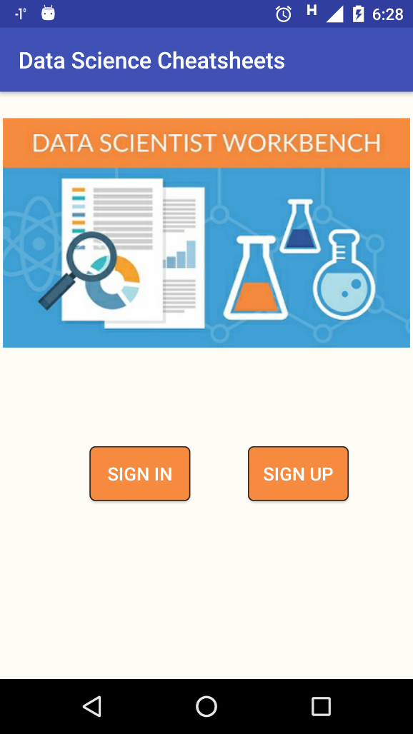

1. **Sign In Activity**

The login activity consists of manual login and Facebook(social) login with all proper validations. I have used Linear Vertical layout and Linear Horizontal layout for this page.

|  |  |
| --- | --- |
| This activity has a manual login, Facebook login and a toggle for Register in the bottom. | When clicked on Facebook login, it connected with my Facebook credentials. We can logout by clicking the Logout button for Facebook. |
| C:\Users\Avni Hardik Mehta.DESKTOP-RM37FMH\Desktop\login1.png | C:\Users\Avni Hardik Mehta.DESKTOP-RM37FMH\Desktop\login3.png |
| Validation for manual login – invalid username/password | Validation for manual login |
| C:\Users\Avni Hardik Mehta.DESKTOP-RM37FMH\Desktop\login2.png | C:\Users\Avni Hardik Mehta.DESKTOP-RM37FMH\Desktop\login4.png |

1. **Sign Up Activity**

I have used Linear Horizontal Layout and Linear Vertical Layout for this page.

|  |  |  |
| --- | --- | --- |
| The sign up activity consists of all required fields and also a toggle for Login in the bottom | Validation for sign up activity | Validation for sign up activity |
| C:\Users\Avni Hardik Mehta.DESKTOP-RM37FMH\Desktop\register1.png | C:\Users\Avni Hardik Mehta.DESKTOP-RM37FMH\Desktop\register2.png | C:\Users\Avni Hardik Mehta.DESKTOP-RM37FMH\Desktop\register3.png |

1. **Home Activity**

The home activity consists of 4 image buttons. I have used Grid layout for this page.

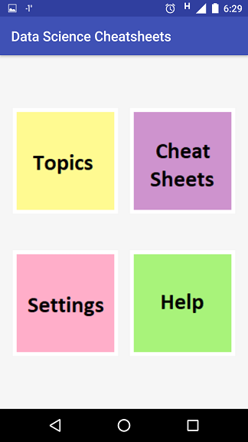

1. **Topics Activity**

The topics activity lists the topics and number of cheatsheets in a tabular format. I have used Table Layout for this page.

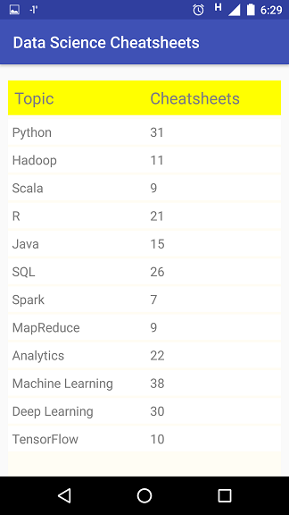

1. **Cheat sheet Activity**

The cheat sheet activity lists all topics in a scrollable list view. When clicked on a topic, a toast says Downloading.

|  |  |  |
| --- | --- | --- |
| List view of topics.. | Scrollable | When clicked on Machine Learning |
| C:\Users\Avni Hardik Mehta.DESKTOP-RM37FMH\Desktop\cs1.png | C:\Users\Avni Hardik Mehta.DESKTOP-RM37FMH\Desktop\cs2.png | C:\Users\Avni Hardik Mehta.DESKTOP-RM37FMH\Desktop\cs3.png |

1. **Settings and Help Activities**

The settings and help activities consists of Linear Layout and Relative layout.

|  |  |  |
| --- | --- | --- |
| Settings – Delete Account | Settings – Logout | Help |
| C:\Users\Avni Hardik Mehta.DESKTOP-RM37FMH\Desktop\settings1.png | C:\Users\Avni Hardik Mehta.DESKTOP-RM37FMH\Desktop\settings2.png | C:\Users\Avni Hardik Mehta.DESKTOP-RM37FMH\Desktop\help.png |

**Code:**

The [source code](https://github.com/AvniM/Web-Mobile/tree/master/Lab/Lab-4/Source/DataScienceCheatsheets) is uploaded to Github.